Lecture 3. Technology of preparation of nanodispersed systems.

There are two general approaches to nanoparticle preparation: “top-down” and “bottom-up” methods.
“Bottom-up” (condensation methods in terms of colloid chemistry) allows obtaining bigger particles from small particles (atoms, molecules, ions). “Top-down” (dispersion) methods are applied for preparation of nanoparticles from bigger particles. In addition, nanoparticles can be prepared by combination and special methods for nanoparticle synthesis.

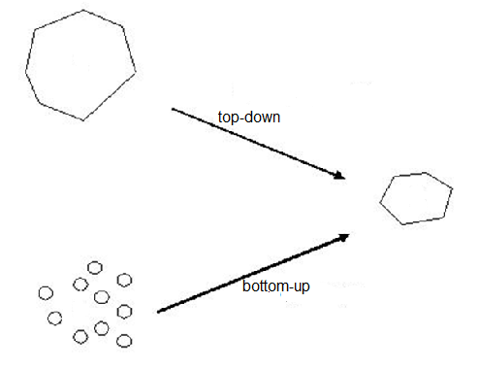
Figure 1 – Methods of nanoparticle preparation

Dispersion methods implies the preparation of colloids/nanoparticles from bulk materials. At top-down process the mechanical milling are used (colloidal mills, ball mills, dispersers, centrifugal milling, ultrasound milling by means of cavitations of solids and liquids, electrosound dispersion etc). Modern dispersion methods allow to produce solid nanoparticles, nanodroplets with monodispersion distribution of particles by sizes.
Condensation methods. These methods allow obtaining the highly dispersed and ultrafine particles, therefore, they are widely used in nanotechnology. Here are given characteristics of the physical and chemical condensation methods.
Physical condensation methods. The base of this method for dispersed particles obtaining is the separation of the new phase particles from vapour (at condensation) or from a liquid (at crystallization). The formation of dispersed particles occurs because of a first-order phase transition. A necessary condition for physical condensation is the deviation of an initial homogeneous system (vapour or liquid) from the state at some particular temperature or pressure.
For example, changes of temperature and pressure are used in aerosol production. Thus, fog forms in a system containing saturated water vapour at temperature decreasing. In the Wilson chamber the formation of fog takes place at adiabatic extension of air saturated with water vapour; that causes supercooling of a system and formation of water droplets. Similar processes of condensation take place in the case of air containing saturated vapours of substances as phosphorus oxide (V), zinc oxide, sulphur, arsenic, etc. In this case, at temperature decreasing solid particles form a smoke.
Method of solvent replacement. This method is widely used for the preparation of solid particles of a colloidal solution (sol). The method implies that a solution of a substance with constant stirring is poured into a liquid in which this substance is practically insoluble. The resulting supersaturation leads to the formation of dispersed particles. Their size is regulated by supersaturation: the larger supersaturation, the smaller particles. By the method of solvent replacement hydrosols of sulphur, phosphorus, rosin and other substances can be obtained because of they are well soluble in organic liquids, but practically insoluble in water.
The organic substances used in the method of solvent replacement must have unlimited solubility in water and a sufficiently high vapour pressure at room temperature. For these purposes usually acetone, ethyl alcohol and isopropyl alcohol and similar solvents are used. The solvent replacement method is used to solve many contemporary nanotechnological problems. For example, by means of this method in 1986 at first time a compound with high-temperature conductivity was obtained.
Chemical condensation methods. Chemical methods leading to the formation of dispersed particles with a particular composition and size.
Chemical reactions with formation of insoluble substances. This method is widely used for the preparation of colloidal solutions (sols or nanosols). It was used by M. Faraday at first time (Table 1, Fig. 3) to synthesize the colloidal gold nanoparticles with a size of 5-20 nm.
The principle of the method is a supersaturation which can be achieved as a result of a chemical reaction with the formation of a new phase nucleus of insoluble compound. The reaction of oxidation, reduction, ion exchange and hydrolysis can be used for chemical condensation method. For example, the formation of gold sol:

HAuCl₄ +2K₂C0₃+H₂O = Au(OH)₃+2CO₂+4KCl

2Au(OH)₃+K₂CO₃ = 2KAuO₂+3H₂O+CO₂

2KAuO₂+3HCOH+K₂CO₃ = 2Au+3HCOOK+KHCO₃+H₂O

Another example is preparation of Prussian blue solution and formation a ferric hydroxide sol:

4FeCl₃+3K₄[Fe(CN)₆] = Fe₄[Fe(CN)₆]₃+12KCl

FeCl₃+3H₂O =Fe(OH)₃+3HCl

As a result of chemical condensation, the micelle of ferric hydroxide (nanosized particle) form:
{m Fe(OH)₃ (n-x)Fe ²⁺(n-x)OH⁺}x OH⁺

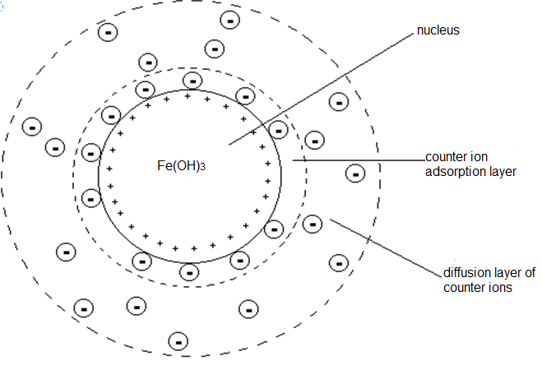

Figure 2 – Dispersed phase nanoparticle obtained by hydrolysis of ferric hydroxide

The size of particles depends on conditions of formation of disperse systems, a ratio of the rates of simultaneous formation and growth of new phase nuclei. In order to obtain the highly dispersed particles, the rate of nucleation of a new phase must be greater than the rate of their growth. These conditions can be reached when a concentration of solution of one of the components is added to the dilute solution of another component under strong mixing. Thus, regulating the rate of formation and growth of the nucleus of a new phase, one can change purposefully the dispersion of system obtained. At low solubility of the compounds obtained during the reaction, large supersaturations and low particle growth rates can be achieved, that leads to the formation of highly dispersed systems.
Two-stage physical (combination) methods are widely used to produce metal nanoparticles. The first stage is dispersion of metal up to atomic dimensions with formation of a vapour; the second stage consists in the subsequent condensation of these vapour and formation of nanoparticles. There are several ways of this techniques.
Method of molecular beams. The initial material is placed in a vacuum chamber with a narrow hole (diaphragm). After heating to sufficiently high temperature, the substance evaporates. Passing through the diaphragm, the evaporated particles form a molecular beam. It is directed to a substrate on the surface of which condensation of the vapour takes place. After that dispersed particles or a thin coating with a thickness about 10 nm are formed.
Aerosol method. Metal evaporates in a rarefied atmosphere of an inert gas. At temperature decreasing the vapours condense and dispersed metal particles are formed with sizes from 1-3 to 100 nm. The aerosol method is used to produce metal nanoparticles (iron, cobalt, nickel, copper, silver, gold, aluminium) and their compounds (oxides, nitrides, sulphides).
Spray drying method. In the first stage, the solution of a substance (for example, salt) is dispersed to small droplets in a stream of heated gas (air). At average temperatures of gas, the solvent evaporates, and a dispersed powder of salt particles are formed as a process product. At sufficiently high temperatures along with the evaporation of the solvent, thermal decomposition of the salt until oxide powder occurs.
Cryochemical synthesis. The main feature of this method is that at first the metal is vaporized in a stream of inert gas (argon or xenon) at intense heating. Then cathode is sputtering by means of electric fracturing or other method. Then the metal vapour condenses on the surface of a substrate at low and ultra-low temperatures in a large excess (by thousands times) of an inert gas. As a result, nanoparticles form on a substrate. Very low temperatures in combination with strong dilution prevent diffusion of nanoparticles along the surface of the substrate, so they keep their small size.
Plasma method. In an inert atmosphere (or with an admixture of hydrogen) electric arc is created. Evaporated material is used as an anode. Very high temperature (up to 7000 K) is created in a stream of vapour emanating from an anode. Outside the arc the temperature of the gas is much lower. As a result, a very high supersaturation of the metallic vapour is reached, that leads to metal vapour condensation up to nanoparticles.
Sol-gel method. This method is used for separation of fine solid particles or nanoparticles from a colloidal solution (sols) under certain conditions, the dispersed particles stick with each other and form a spatial gel structure. At the result of the fast drying of the gel a powder of fine particles is formed.
A method of supercritical drying consists in heating of wet gel in a closed apparatus, so that the pressure and temperature exceed the critical values of temperature and pressure of the liquid, which is in the pores of the gel. As a result, a wet gel is converted into a highly porous airgel with very small (up to 2 nm) pores. Overall, supercritical drying of gels allows to obtain gas nanodispersed particles (pores).
Synthesis of nanoparticles in microreactors. For many technological processes (for example, in microelectronics) the particles would have a small size distribution and monodisperse. To obtain monodisperse nanoparticles with desirable sizes the chemical synthesis is carried out in microreactors or so called nanoreactors. As nanoreactors can be applied the disperse systems:
- microemulsions
- micellar systems
- highly porous substances (for example, zeolites)
Microemulsions are transparent liquid (or slightly opalescent) fine disperse and thermodynamically stable systems. Microemulsions are distinguished as direct (oi-in-water) and reverse (water-in-oil) microemulsions. The size of the water droplets can vary within wide limits from 1-3 to 100 nm depending on the preparation terms of microemulsion and nature of surface active stabilizers.
A microdroplet in this case can be considered as a microreactor in which a new phase is formed. The size of particle obtained takes the size and the shape of microdroplets. By this method nanoparticles of spherical form is prepared and also filamentary nanoparticles of metals, metal oxides and sparingly soluble salts can be obtained.
The method of ultrafine particle preparation in micellar systems is called as a template synthesis. The method has some advantages. Depending on the concentration of surfactant solution, the micelles have different shapes: spherical (at low concentrations) and cylindrical (at high concentrations). Due to this, the simulate synthesis allows obtaining particles of different dimension: three-dimensional particles in spherical micelles, two-dimensional particles (nanofibers). Another advantage of the method is simple purification the particles from the templates (surface-active substances).
In addition, synthesis of nanoparticles in nanopores is widely used due to the possibility of obtaining particles of very small dimensions and a narrow pore size distribution. Using this method, for example, gold nanoparticles of about 2 nm in zeolite pores were synthesized.

Revision questions:

- What are “top-down” and “bottom-up” methods?
- What dispersion methods are used for nanoparticle production?
- The basic principles of physical condensation methods.
- Describe the chemical condensation method.
- What is an aerosol method? What particles can be prepared by this method?
- Characterize the two stages methods.
- Describe the features of cryochemical synthesis.
- Condition that influence on the size of particles.
- Give the examples of nanoreactors.
- Consider advantages of template synthesis.

